PRESIDENT’S OFFICE
REGIONAL ADMINSTRATION AND LOCAL GOVERNMENT
NAMANGA SECONDARY SCHOOL
FORM FOUR SERIES ONE EXAMINATION-2024
BIOLOGY

Time 2:30 Hours

INSTRUCTIONS
- This paper consists of section A, B and C with total of the 10 questions
- Answer all question from section in each section
- Section A and C carries fifteen (15) marks each and section B carries seventy (70) marks.
- All writing must be in blue or black EXCEPT drawing which must be in pencil.
- Cellular phones and any unauthorized materials are not allowed in this examination room
- Write your assessment Number at the top right hand corner of every page.

SECTION A (15 Marks)
Answer all questions in this section
- For each of the items i-x choose the correct answer from the given alternatives and write the letter in the box provided.
  - Which of the following organism are members of the kingdom protoctista?
    - Bacteriophage and paramecium
    - Euglena and yeast
    - Plasmodium and amoeba
    - Bacteria and trypanosome

  - Why a grasshopper called herbivore?
    - It feeds on animals
    - It feeds on bacteria
    - It feeds on fungi
    - It feeds on plants

  - One of the following characteristics is used to identify procedures in the ecosystem
    - Making their own food
    - Feeding on other organism
    - Growing on the fertile soil
    - Feeding on already made food

  - Caring for people living with HIV and AIDS is important because
    - It can cure AIDS
    - It gives the victim hope
    - It makes the victim depressed
    - It shortens victim’s life span

  - Which of the following is recommended as a first aid procedure for a victim who has been stung by a bee?
    - Giving plenty water to the victim
    - Applying baking soda paste on the bee stung area
    - Leaving the cotton on the stung area few minutes
    - Giving oral rehydration drink to the victim

  - The residents of a certain village in Iringa feed on meat, beans and ugali. In order to improve their heath which of the following foods would you recommend to add present diet?
    - Fish and sweet potatoes
    - Bread and green vegetables
    - Cassava and fruits
    - Fruits and green vegetables

  - Which one of the following is the list of animal tissues?
    - Muscle, blood and bone
    - Brain, bone and liver
    - Skin, heart and brain
    - Muscle, liver and skin

  - A child has deformed bones, soft bones and sometimes experience bone pain. This child has deficiency of?
    - Vitamin E and calcium
    - Vitamin D and Zink
    - Vitamin A and Vitamin
    - Vitamin D and calcium
  - The structure of a plant cell which makes it to be firm and rigid is
- Vacuole b. Cell wall
- Plasma membrane d. Nucleus
  - Which of the following is not an art that shows good manners towards other?
    - Dressing smartly when meeting other
    - Covering your mouth sneezing, coughing, or yowling
    - Abusing people who do not behave responsibly
    - Listening other when they are speaking
- Match the phrases in LIST A with responses in LIST B by writing the letter of the correct response from list B below, The item number of LIST A in a table below
LIST A | LIST B
- A disease transmitted through sexual intercourse treated antibiotics  - A viral disease transmitted through sexual intercourse  - A disease characterized by favour and coughing of blood system  - A disease speared by an agent known as anopheles  - A disease caused by lack of proper hygiene and victim had a stool of rice water colouration. | - Cholera  - Typhoid  - AIDS  - Malaria  - Syphilis  - Common cold  - Schist soma  - tuberculosis
SECTION B (70 MARKS)
Answer all questions in this section
- a) Identify seven life processes that occur in all living things that make them different from non- living things.
b) If the magnification power of the eyepiece lens is X10 and the total magnification of a specimen is X400, work out the magnification power of the objective lens.

- a) State one role played by the following substances in digestion
- Hydrochloric acid
- Bile
- Saliva
- How do animals like human being benefits from the process of photosynthesis occurring in plants? ( two points)
- Name two components of pancreatic juice and states its role for each component

- A biologist classified bats and cows into the same ground because they have mammary gland and breast food their new born babies.
- Which classification system did the biologist use/
- Briefly explain four (4) merits of the classification system used in 5(a)

- Bread was placed in wet cupboard. After a few days, black thread like structures which ended up in club like structures appeared on the bread.
- Write the common name of the organism that grew on the bread surface
- Name of kingdom in which the observed organism belongs
- Name the phylum in which the observed organism belongs
- Outline six (6) advantages of the members of the kingdom you mentioned in (b) above.
- a) Arrange the following cellular organization in ascending order Organelle, Tissue, Organ, Cell, organism, system
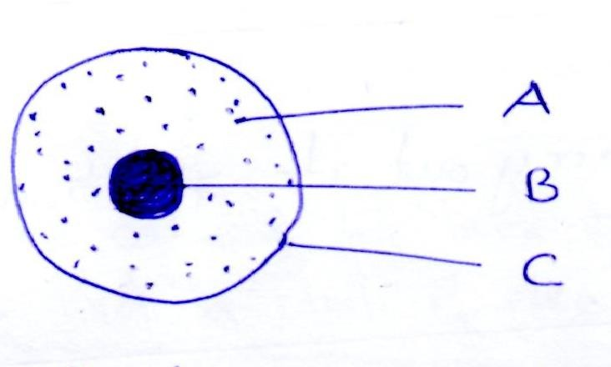
b. Study the following diagram then answer the following questions

i. State the function of part labeled A, B and C

- Write three similarities between plant cell and animal cell

- Form II students performed an experiment to determine food substance contained in sample N. They took 2 cm3 of sample M into a test tube. They then added equal volume of sodium hydroxide followed by three drops of copper ii sulphate solution. A purple coloration was observed.
- Which food substance was present in sample M?
- State two functions of the food substances that was present in sample M
- Name the part of the alimentary canal in which the food present in sample M is firstly digested.
- Identify three (3) natural sources of food substances contained in sample M
- Give three systems of the disorder of food substance contained in sample M when it’s insufficient in children.
- John accidentally falls in the class and was found that he was not breathing. The student helped him to recover from breathing problem.
- What is the name of the process done by students?
- Give out the five (5) reasons of giving the process above?
- Give two (2) precautions that should be taken while performing the process above

SECTION C (Marks)
Answer question ten (10)
- Every building has some features depending on the purpose for which it was designed. As a good student of form four, explain any six(6) features of a good laboratory

